What are decision trees
Myles et al. provide an overview of decision trees in their paper. It is introduced as a versatile method for classification and regression tasks [1]. Data is split into branches based on feature values, creating a tree-like structure, where the tree starts with a root node, and each decision node is a decision rule whereas each leaf node is the outcome.
Classification trees use criteria such as Gini impurity or classification error rate to split the tree [2]. However, the issue with this is that a single tree is prone to overfitting and cannot handle complex data patterns.
Random forest is an ensemble learning algorithm that prevents overfitting while improving accuracy [3]. It produces multiple decision trees by bagging, after which, the independent predictions are averaged for the final output.

Why random forest
- Can handle both categorical and numerical data
- Ensemble approach, hence, reduces the risk of overfitting in a dataset with complex patterns
- Provides feature importance scores that assist with understanding significant factors in the data
- Good at handling imbalanced data classes, and non-linear relationships, which can be seen in the dataset

Steps to implement decision trees
- Data preprocessing: data is pre-processed as per pre-processing steps
- Data split: data is split into test, train, and validation i.e. 65, 20, and 15 respectively
- Train the model: use the split data to train the random forest model
- Evaluate: evaluate the model using performance metrics that include accuracy, precision, recall, F1-score, and AUC.
- Fine tuning: fine tune the hyperparameters to improve the performance

Goal
Apply Random Forest algorithm on data clustered by the k-means algorithm to train the model to predict which cluster a patient belongs to. By doing so, the likelihood of the patient being in a cluster, and hence their chances of having MI, can be analysed.

Tuning
It was noted that the clusters were not normally distributed, hence while initializing the classifier, the class weight was set to balanced to account for any minor imbalances. Furthermore, the GridSearch function provided by scikit-learn was used to evaluate the model with different hyperparameters, as seen in Figure 1 below. The best results were then cross-validated and used for training the model.
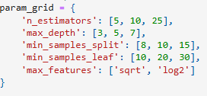
Figure 1 - GridSearch

Results

Validation
The validation results show a 92.70% accuracy, along with consistent precision, recall, and F1 score, as seen in Figure 2 below.
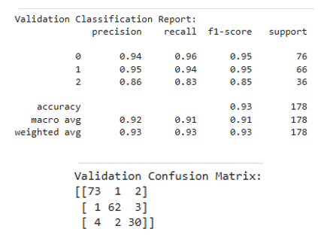
Figure 2 – RF Validation Classification Report

Cross-validation
k-fold cross validation was performed to analyse the consistency of the model, where k was taken as 5. The mean cross-validation accuracy was noted to be 91%, where the standard deviation is 0.02. These values show that the model’s performance is good and consistent across classes.

Test
The test accuracy is 90.03%, with other score values in a similar range as seen in Figure 3 below.
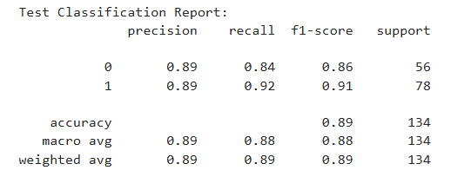
Figure 3 – RF Test Classification Report
The confusion matrix in Figure 4 shows that the model has achieved a balanced performance for all 3 clusters.
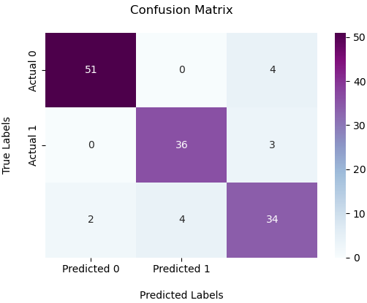
Figure 4 – RF Test Confusion Matrix
The ROC Curve generated by the test set, as seen in Figure 5 below, indicates a low false positive rate while classifying clusters correctly. The AUC scores suggest that the model is reliable for predicting the patient cluster.
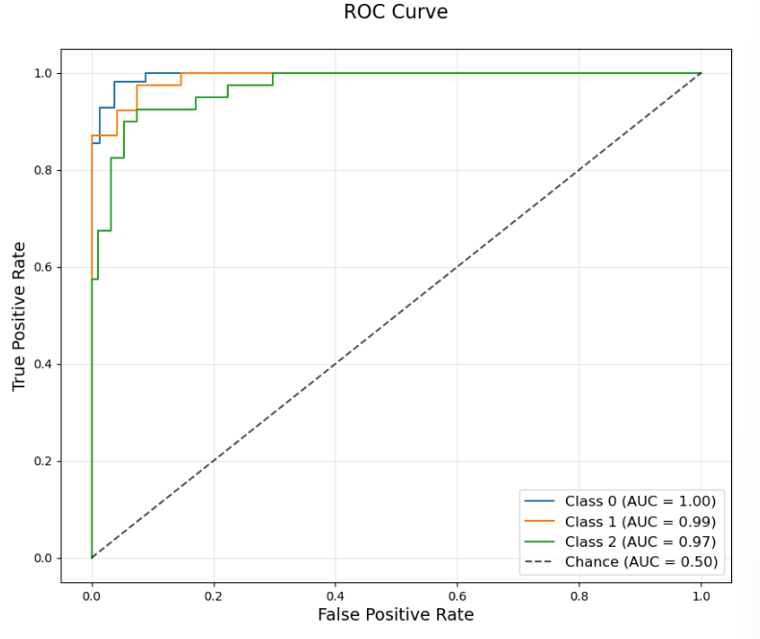
Figure 5 - RF Test ROC Curve

Findings
After implementing decision trees to predict patient clusters, the results have shown that clinical data has a significant predictive power, showing that it contributes greatly for making accurate cluster predictions, which in turn are used to understand the chances of a patient suffering with MI.
The accuracy resulting form a single decision tree is moderate, however, it is noted that the tree tends to overfit, limiting its ability to generalise well to unseen data and struggling with complex patterns.
Extending the decision tree with the Random Forest algorithm shows a balanced performance of the model, providing a reliable method for predicting patient clusters i.e. based on clinical data. This, in turn, aids the assessment of MI risk

Bibliography

[1] | A. J. Myles, R. N. Feudale, Y. Lui, N. A. Woody and S. D. Brown, "An introduction to decision tree modelling," Journal of Chemometrics, vol. 18, no. 6, pp. 275-285, 2004.
[2] | R. D. Joshi and C. K. Dhakal, "Predicting Type 2 Diabetes Using Logistic Regression and Machine Learning Approaches," International Journal of Enviornmental Research and Machine Learning Approaches, vol. 18, no. 14, p. 7346, 2021.
[3] | Y. Sun, H. Cheng, S. Zhang, M. K. Mohan, Y. G and G. De Schutter, "Prediction & optimization of alkali-activated concrete based on the random forest machine learning algorithm," Construction and Building Materials, vol. 385, p. 131519, 2023.

